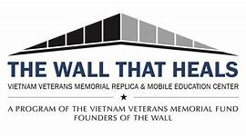
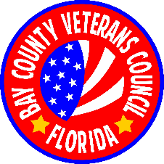
The Wall That Heals
Donation Form

Donor Organization or Name ________________________________________________________
(As to be published)

Contact Name: ___________________________________________________________________

Email: __________________________________________________________________________

Address:

Telephone:

Please make checks payable to:
The Bay County Veterans Council
Write: The Wall That Heals in the memo line and send to:

mail to: The Wall That Heals
Bay Co Veterans Council,
8108 Heritage Woods Lane
Callaway, FL 32404

