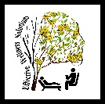

***Our STEM program is designed to teach 3rd through 10th grade students science, technology, engineering and math techniques that will stimulate creativity, encourage thinking and develop problem solving skills. Day Camp is to cover the weeks in between so parents can keep their children in the same program.***

**CAMP UNLIMITED**

***Unlimited Dreams Unlimited Possibilities***

**SUMMER STEM CAMP & SUMMER DAY CAMP**

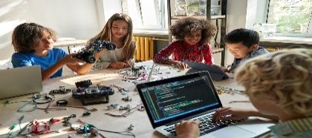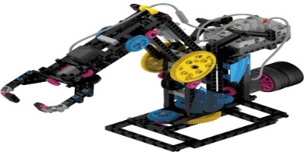

Effective Wellness Solutions has launched a new STEM program designed for students. This program integrates science, technology, engineering, and math (STEM) to encourage critical thinking skills. We will have four sessions beginning **June 3, 2024, through July 26, 2024, from 7:30 am to 5:30 pm** (*extended hours are available for an additional fee*). The project-based learning system will foster logical analysis, experimentation, and innovative thinking to encourage a positive outlook for future careers. Tuition is $150 per session, $425 for 3 sessions, $550 for 4 sessions. Multiple session discounts must be paid altogether and at the same time. Lunch and snacks are provided. **Day Camp is available for the weeks in between. Please call or check the website for these fees.** Limited scholarships and sibling discounts are available for both camps. For more information visit **ewellsol.com** **or call 850-821-2126**.

**SESSION 1 ~ Sensational Science * June 3 – June 7 (week 1)**

Learn to observe and describe the natural surroundings by identification and experimentation. Pursue knowledge and understanding by exploring quality, structure, and space.

**(Week 2 & 3 Regular Day Camp for an additional fee)**

**SESSION 2 ~ Riveting Robotics * June 24 – June 28 (week 4)**

Use innovative technology to advance and create new devices to produce, modify, and build imaginative robots.

**(Week 5 & 6 Regular** **Day camp for an additional fee)**

**SESSION 3 ~ Engineering Ingenuity * July 8 – July 12 (week 7)**

Explore the process of creating and building structures using math and science to design, enhance, plan, and construct materials for engineering projects.

**(Week 8 Regular Day Camp for an additional fee)**

**SESSION 4 ~ Measurable Mathematics * July 22 – July 26 (week 9)**

Discover the study of numbers and how to measure, formulate, quantify, and compute mathematical equations related to each other and the real world.

**(Week 10 Regular Day Camp for an additional fee)**

**Summer Program Hours**

**7:30 am – 5:30 pm**

**Monday-Friday**

**730 Jenks Ave**

**Panama City, FL 32401**

**850-821-2126**

**Ewellsol.com**