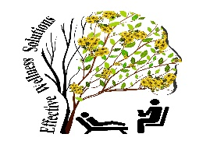
Effective Wellness Solutions
730 Jenks Ave, Panama City, FL 32401

Hello,

My name is Evelyn Budd, and I founded Effective Wellness Solutions. This organization is focused on wellness in all aspects of life. One concern that has come to my attention is the increased cost of summer programs for working parents. This dilemma can increase stress and anxiety in the lives of working parents, attributing to the disturbance of mental well-being. With that in mind, I am offering a new, affordable summer day camp. The purpose of this camp is to provide quality care and service to students during working hours at an affordable rate to parents. For this endeavor to succeed, I need the support of the community.

I am looking for donations in the area of:
- Tuition assistance (sponsor a child)
- Volunteers
- Arts and crafts materials
- Eleven more laptops

Coretta Scott King said, “The greatness of a community is most accurately measured by the compassionate actions of its members,” Helen Keller said, “Alone, we can do so little; together, we can do so much.” Please join with Effective Wellness Solutions in our efforts to offer an affordable summer day camp to our community.
Thank you,
Evelyn Budd
Evelyn Budd
Effective Wellness Solutions
Owner
850-821-2126

