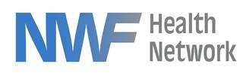

Independent Living

2022 Christmas Sponsorship

**The Independent Living program for NWF Health Network aims to provide Christmas gifts to each young adult (ages 18-23) in the program each year. These young adults have lived foster care experience and are often living on their own while working and/or going to school. They are working hard to achieve their goals and break the cycle of trauma they experienced as a child. Sponsoring them at Christmas time is a simple way to let them know they have support.**

**For more information on sponsoring the Independent Living Program’s Christmas drive please contact:**

**Kecia Crawford 850-866-1235** [**Kecia.Crawford@nwfhealth.org**](mailto:Kecia.Crawford@nwfhealth.org)**.**

**Gifts Cards need to be turned in by Dec. 9th.**

**Donor Commitment**

Name: Phone Number:

Address:

**SPONSORSHIP LEVEL:**

* **Bronze:** $10 Gift Card
* **Silver**: $25 Gift Card
* **Gold**: $50 Gift Card
* **Platinum**: $100 Gift Card
* **Premier**: Sponsor a wish list for a specific young adult